|  |  |
| --- | --- |
|  | **FPT ACADEMY INTERNATIONAL**  **FPT – APTECH COMPUTER EDUCATION** |

**Centre Name: ACE-HCMC-2-FPT.**

**Address: 590 Cach Mang Thang 8, District 3, Ho Chi Minh City, Viet Nam.**

**HAIRCARE**

|  |  |  |
| --- | --- | --- |
| **Supervisor.** | Mr. Nguyen Phat Tai | |
| **Batch.** |  | |
| **Group.** | Group 3 | |
| **Serial No.** | **Enrollment Number** | **Student Name** |
| 1. | Student1285595 | Vu Duy Khanh |
| 2. | Student1286087 | Do Thanh Nam |
| 3. | Student1280925 | Truong Le Thien Quang |
| 4. | Student1279121 | Bui Minh Hoang |

Month 03 Year 2021

**This is to certify that**

**Mr.:**

Vu Duy Khanh

Do Thanh Nam

Truong Le Thien Quang

Bui Minh Hoang

**has successfully designed & developed**

eProject: HairCare website

**Submitted by:**

Vu Duy Khanh

**Date of issue:**

**Authorized Signature:**

**TABLE OF CONTENTS**

FPT – APTECH COMPUTER EDUCATION 1

ACKNOWLEGMENT 4

SYNOSIS 4

PROBLEM DEFINITION 4

CUSTOMER'S REQUIREMENTS SPECIFICATIONS (CRS) 5

Business/Project Objective: 5

Hardware/ Software Requirements: 6

SCOPE OF THE WORK (IN BRIEF) 7

Architecture and design of the system 8

Diagram of the website 9

TASK SHEET REVIEW 1 10

# ACKNOWLEGMENT

On behalf of all the members of group 3, I would like to thank you all for the hard works, supports to make this eProject complete successfully. Especially, Mr. Nguyen Phat Tai, our teacher, he helped us a lot from the day that we started to study at FPT Aptech. With this eProject, he has guided us with his enthusiasm and rigorous, because of his guiding, we would be able to finish this project. Besides, I want to thank all the team member of group 3, each of the team members has been working continuously in 4 weeks in order to complete this project. The last but not least, we would like to say thank you to our family for always supporting us, creating the best conditions for us to focus on the project, and putting faith in the dreams we pursue.

# SYNOSIS

Hair is probably one of the first things you notice about people when meeting them for the first time. This is especially true for women. Beautiful and shiny hair always leaves good impression, which is why proper hair care is important. Also, good care of your hair plays an important part in having healthy hair and helps avoid extensive damage that can lead to **hair loss**. Regular washing with celebrity advertised shampoos and conditioners is not enough. To have a healthy, strong and shiny hair, you need to know how to care for it daily.

# Since the field is really vast, a need is felt that there should be a single platform which will give the complete information of haircare

# PROBLEM DEFINITION

The Web site is to be created based on the following requirements.

1. Home page with suitable logo and images, making use of sections.
2. Categorized menu which will include various categories as type of treatments available for various different hair problems like
   1. Hair loss
   2. Graying
   3. Growth related
   4. Premature baldness etc
3. The site should also include the various easy home remedies that can be helpful in dealing with various hair related issues
4. There should be a section which will provide the details of hair care equipments like
   1. Dryers
   2. Straightners
   3. Spray bottles
   4. Steamers
   5. Massagers
   6. Spa caps
5. There should also be a section for hair care products as
   1. Hair cream
   2. Shampoo
   3. Conditioners
   4. Masks
   5. Serums
   6. Hairsprays
   7. Various hair oils
6. Along with the various equipments, there should also be user manual/guidelines for ease of its use and maintenance.
7. The site should also include the details as of which companies provide which equipments
8. Comparison among the same equipment of different companies should be possible based on availability, cost major features
9. Gallery section should include most common instruments along with their necessary details.
10. There should be a section which will enable user to know latest developments in the field
11. Contact us page: contact us details with location should be displayed using GeoLocation API (eg. GoogleMaps).
12. Navigation needs to be smoother.
13. The look and feel of the project must be made user friendly and uniformity in the color combination must be maintained.

# CUSTOMER'S REQUIREMENTS SPECIFICATIONS (CRS)

**Client: HAIRCARE**

### Business/Project Objective:

The Objective of this program is to give a sample project to work on real life projects. These applications help you build a larger more robust application.

The objective is not to teach you HTML/JavaScript/Dreamweaver/HTML5 but to provide you with a real life scenario and help you create basic applications using the tools.

You can revise the chapters before you start with the project.

This project is meant for students who have completed the module of ***HTML5***. These programs should be done in the Lab sessions with assistance of the faculty if required.

It is very essential that a student has a clear understanding of the subject. Students should go through the project and solve the assignments as per requirements given.

Kindly get back to eProjects Team in case of any doubts regarding the application or its objectives.

**Input to the system:**

* + - * Browsing products based on brands, type of hair care products.

**Output from the system:**

* A menu that will categorize all the functions of the site.
* Display the list of available albums category wisely.
* Perform the search based on a particular: brands, type of hair care products.
* Site should be able to provide brief introduction/history about the showroom under About Us page.
* The location of the showroom under Contact-Us page.
* Besides the above requirements, the site should have look and feel as per the industry standards.

**Expected delivery date:** 26-March-2021.

**List of deliverables:**

* + - * Document Word.
      * User Guide.
      * Source code.

### 

### Hardware/ Software Requirements:

* **For developer**

**Hardware**

* + Intel Pentium 4 processor or higher
  + 1 Gigabytes of RAM or higher

**Software**

* + Windows 7 OS or higher
  + Adobe Dreamweaver
  + Web browsers such as IE, Chrome or Firefox are supporting HTML5, CSS3 and Javascript.
* **For web users**

**Hardware**

* + Intel Pentium 4 processor or higher
  + 512 Megabytes of RAM or higher

**Software**

* + Windows XP OS or higher
  + Web browsers such as IE, Chrome or Firefox are supporting HTML5, CSS3 and Javascript.

# SCOPE OF THE WORK (IN BRIEF)

After a long and detailed discussion, our group has decided to create a website contain the following webpages:

1. ***Homepage***: Display information about newest-selling products, an introduction about HairCare.
2. ***Brands***: Display all models of brands based on category (Dryers, Spray bottles, Shampoo, Conditioners, Masks, Serums,…).
3. ***Type of HairCare Products***: Give information about “KIEHL’S”, “CLEAR”, “Head & Shoulder” etc.
4. ***About Us***: Display the information of the company and about us.
5. ***Contact***: Display the address of the company, allow customers to request any information they want from HairCare.

# Architecture and design of the system

Webpage request



Requested Page

**RENDERING**

**ENGINE**

**CSS CODE**

**HTML CODE**

**WEB SERVER**

**WEB BROWSER**

**CLIENT**

**SERVER**

# Diagram of the website

.

HOME

PRODUCT

CONTACT US

ABOUT US



# TASK SHEET REVIEW 1

|  |  |  |  |  |  |  |  |
| --- | --- | --- | --- | --- | --- | --- | --- |
| **Project Ref. No.:**  **eP/Advertisement Portal Management**  **System/01** | | **Project Title:** | **Activity Plan Prepared By:** | **Date of Preparation of Activity Plan:** | | | |
| **Sr.**  **No.** | **Task** | **Actual**  **Start Date** | **Actual Days** | **Team**  **Mate Names** | **Status** |
| 1 | Problem Statement | HairCare | Khanh | 3-Mar-2021 | 1 | Nam | Completed |
| 2 | Analysis of HairCare requirements about the website | 3-Mar-2021 | 1 | Quang | Completed |
| 3 | The scope of the work (in brief) | 3-Mar-2021 | 1 | Hoang | Completed |
| 4 | Architecture and design of the system | 3-Mar-2021 | 1 | Khanh | Completed |
| 5 | Diagram of the website | 3-Mar-2021 | 1 | Khanh | Completed |
| 6 | Task Sheet | 3-Mar-2021 | 1 | Khanh | Completed |

|  |  |
| --- | --- |
| **Date:** | |
| Signature of Instructor:  **Mr. Nguyen Phat Tai** | Signature of Team Leader:  **Mr.Vu Duy Khanh** |

# SITE MAP

PRODUCT PAGE

PRODUCT

CONTACT US PAGE

CONTACT US

ABOUT US PAGE

ABOUT US

HOME PAGE

BLOG NEWS PAGE

BLOG NEWS

# MOCK OF THE WEBSITE

1. **Homepage**

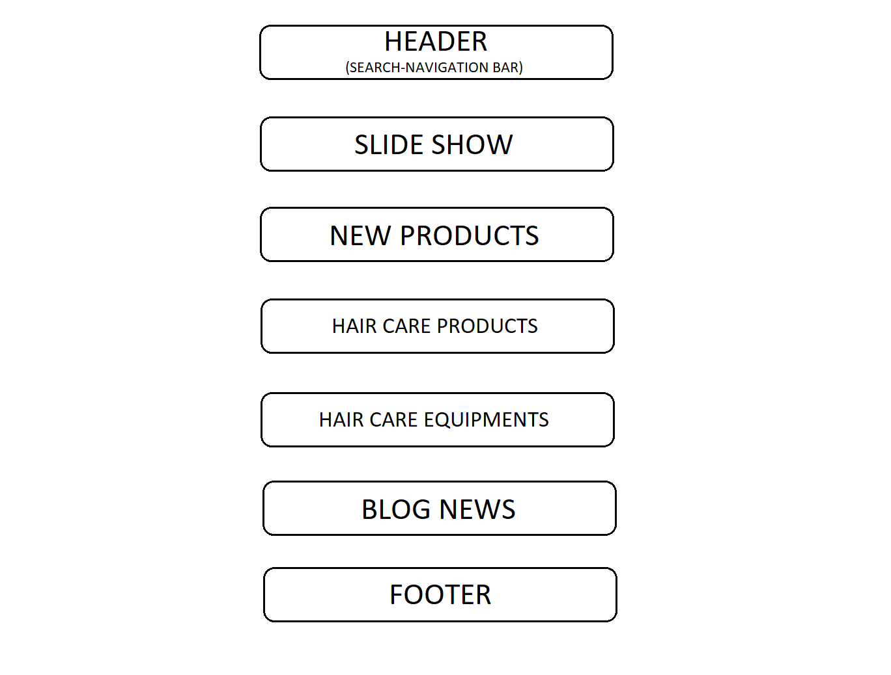

1. **ABOUT US**

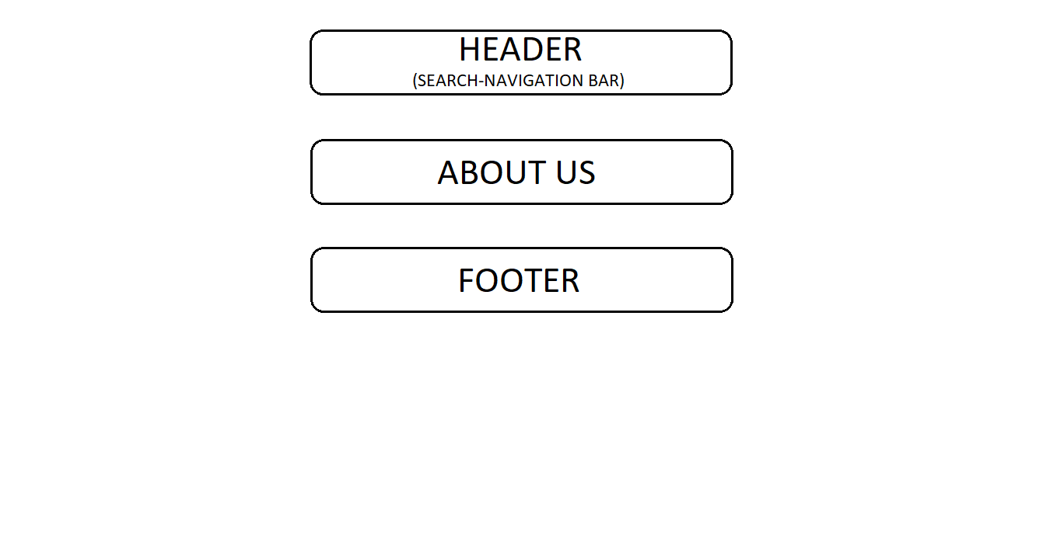

1. **CONTACT US**

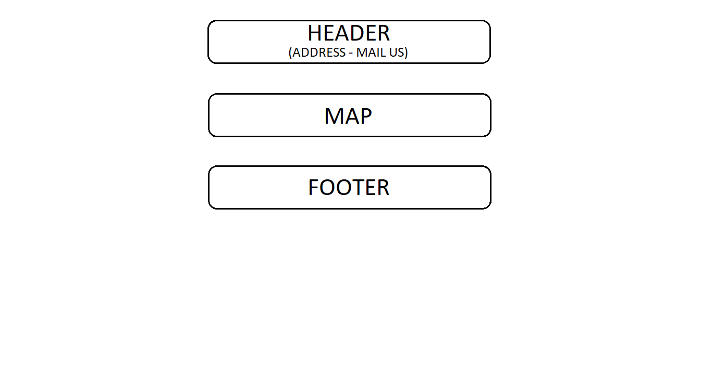

1. **PRODUCTS**

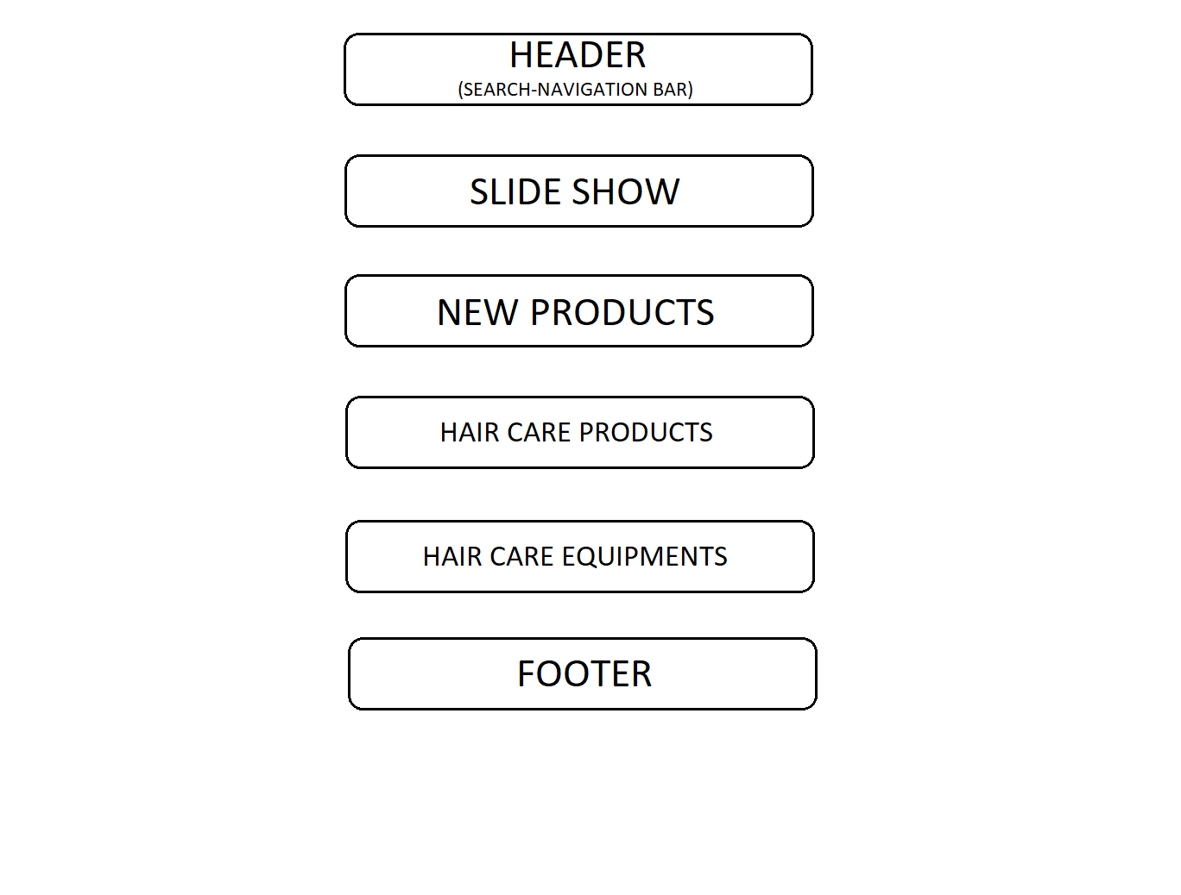

1. **BLOG NEWS**

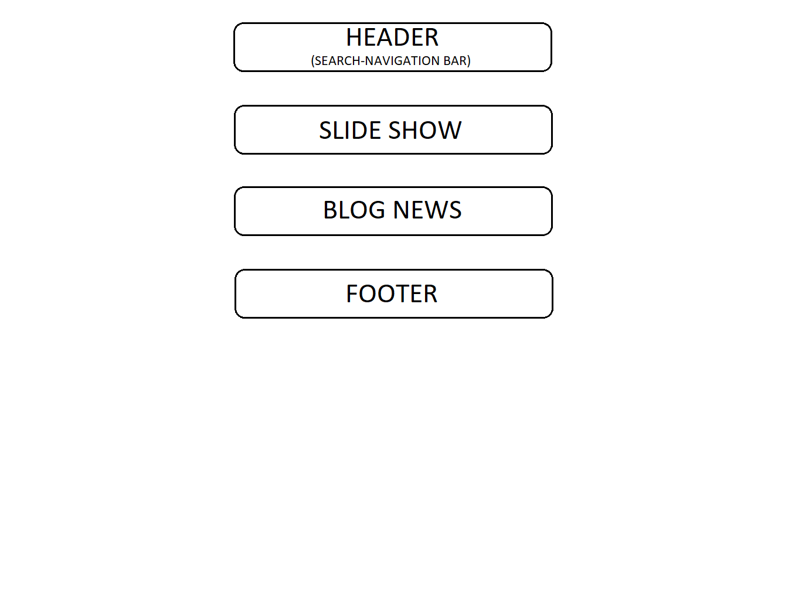

# 

# TASK SHEET REVIEW 2

|  |  |  |  |  |  |  |  |
| --- | --- | --- | --- | --- | --- | --- | --- |
| **Project Ref. No.:**  **eP/Advertisement**  **Portal Management System/01** | | **Project Title:** | **Activity Plan Prepared By:** | **Date of Preparation of Activity Plan:** | | | |
| **Sr.**  **No.** | **Task** | **Actual Start Date** | **Actual Days** | **Team Mate Names** | **Status** |
| 1 | Site map | HairCare | Khanh | 05-Mar-21 | 1 | Khanh | Completed |
| 2 | Mock of the website | 05-Mar-21 | 1 | Quang | Completed |
| 3 | Task sheet | 05-Mar-21 | 1 | Nam | Completed |

|  |  |
| --- | --- |
| **Date:** | |
| Signature of Instructor:  **Mr. Nguyen Phat Tai** | Signature of Team Leader:  **Mr. Vu Duy Khanh** |

# WEBSITE DESCRIPTION

1. **Home Page**

* Description

Home page displays following information:

* Feature promotion product of company.
* Hair care products and hair care equipments.
* Blog News about hair care.
* Screenshot

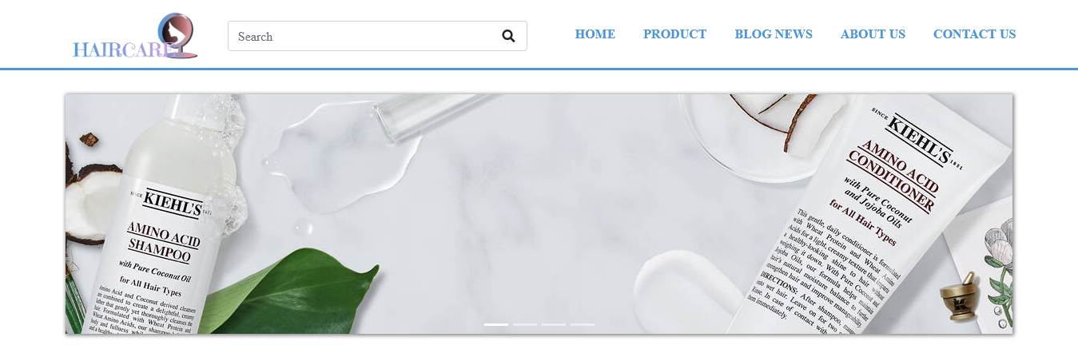

Hair care products and hair care equipments

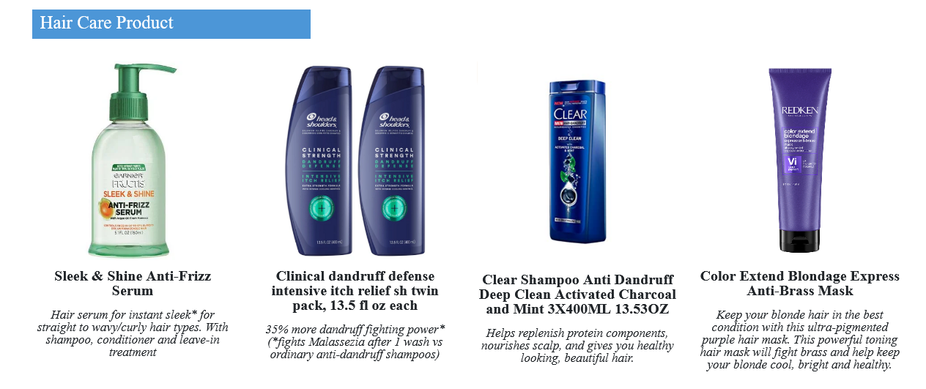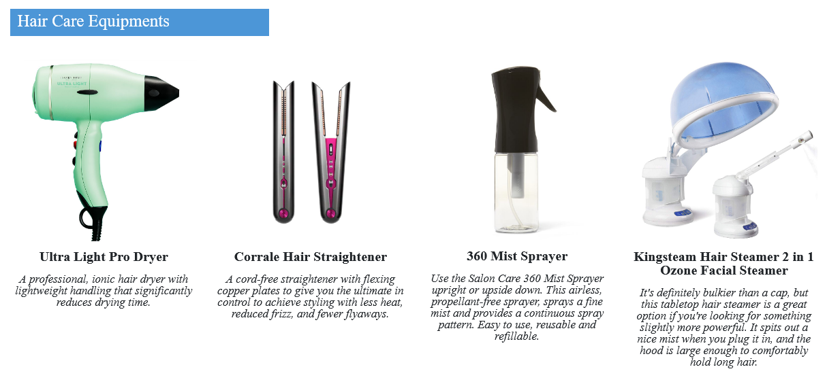

Blog News about hair care

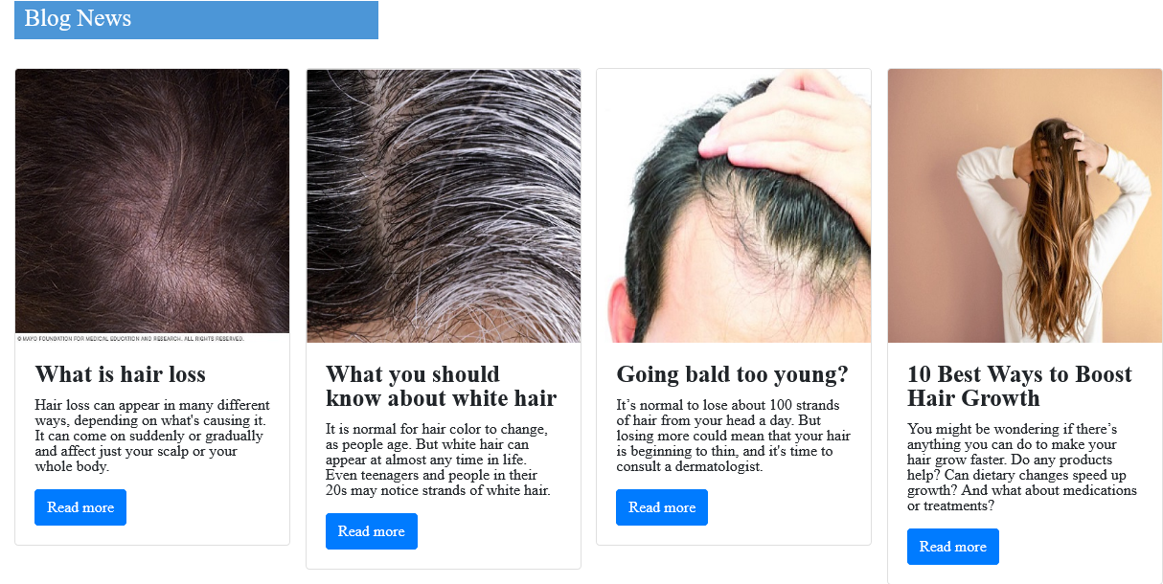

1. **About us**

* Description

This page displays information about the history of HairCare.

Screen shot

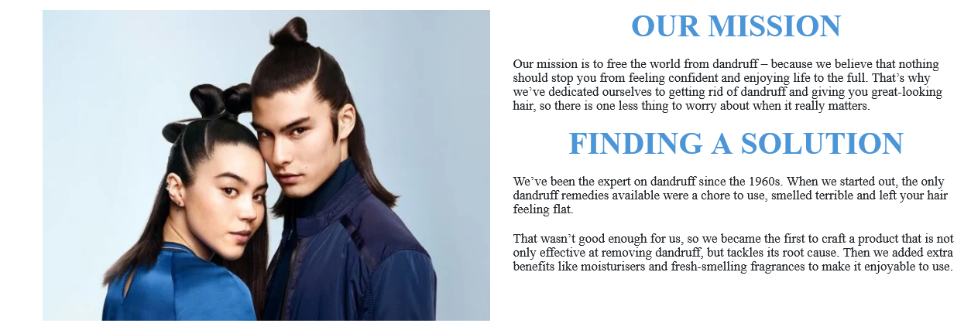

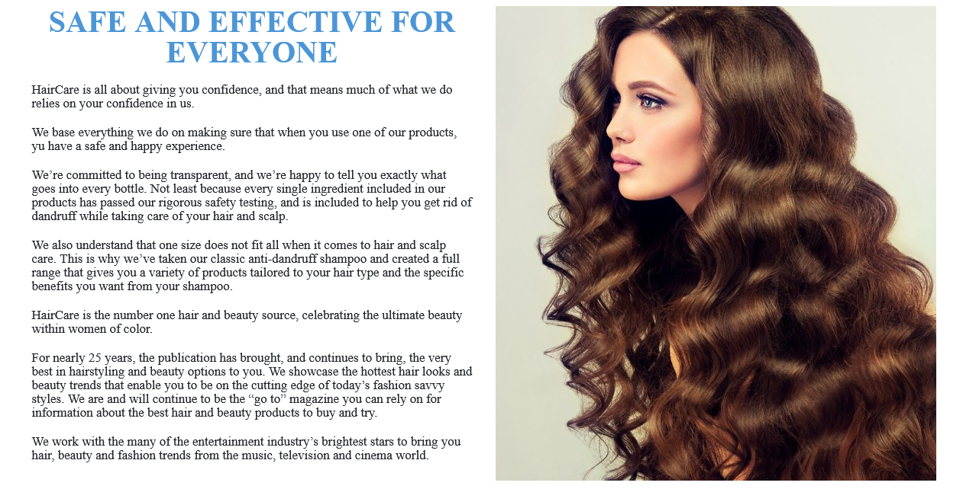

1. **Contact us:**

* Description

This page displays contact information: location, telephone number, email and a quick contact form for customer.

* Screen shot

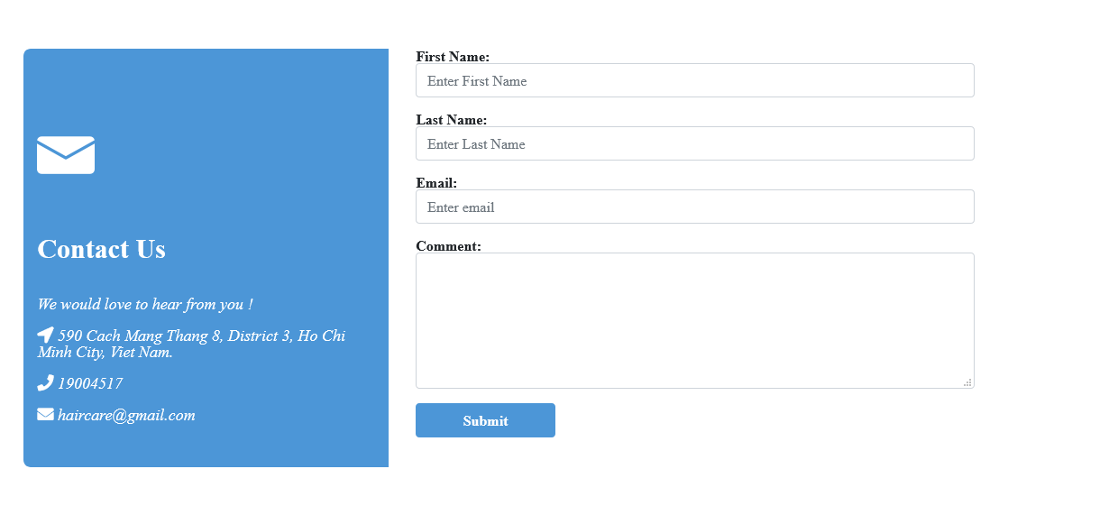

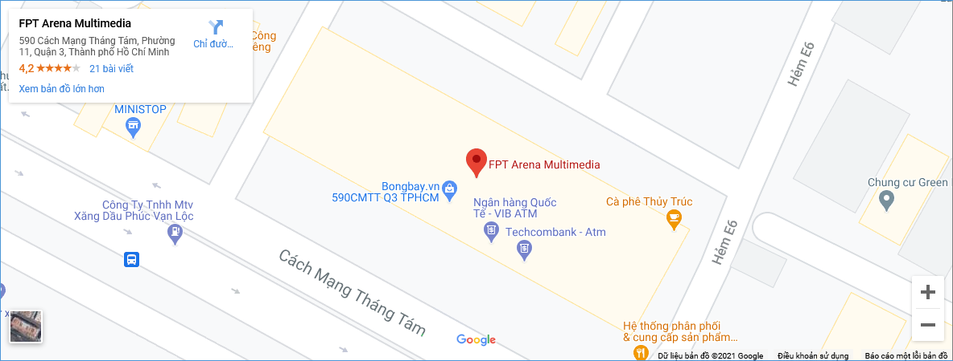

1. **Product:**

* Description:

This page displays following information:

All product that being sold at HairCare (dryers, straightners, shampoo, conditioners, serums), when click on 1 specific item, it will show the detail of that item

* Screen shot

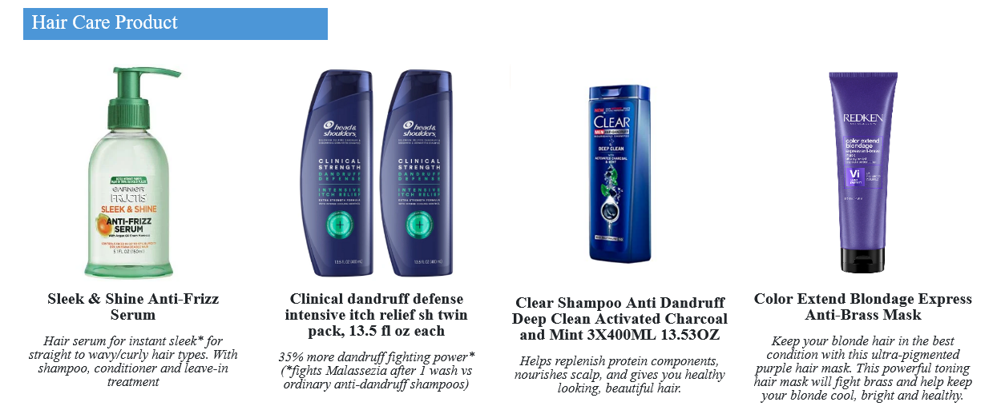

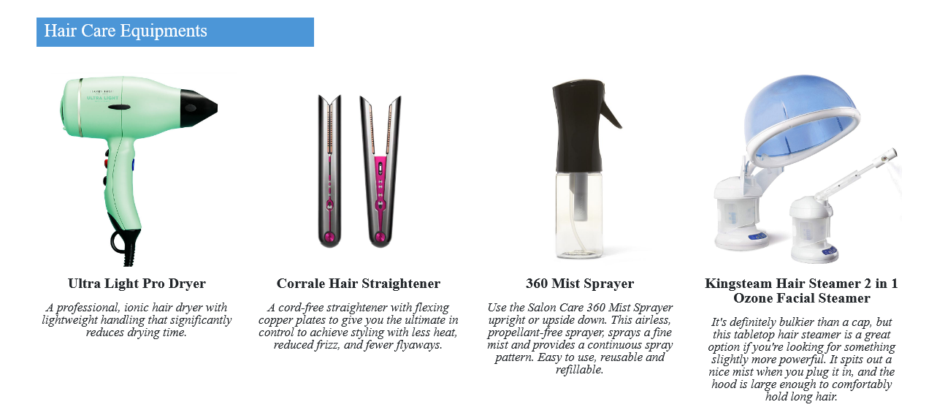

Detail product:

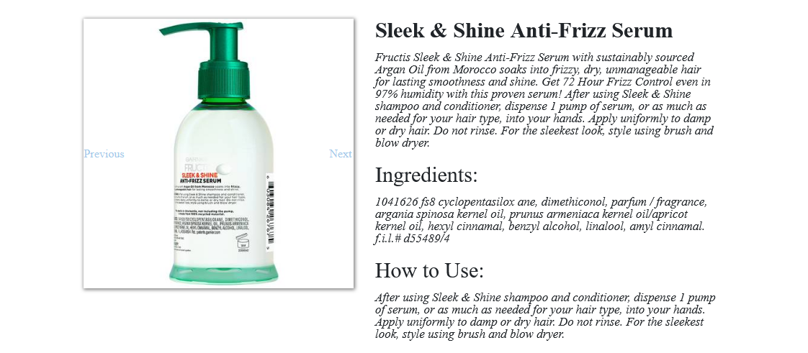

**HTML AND CSS DESCRIPTION**

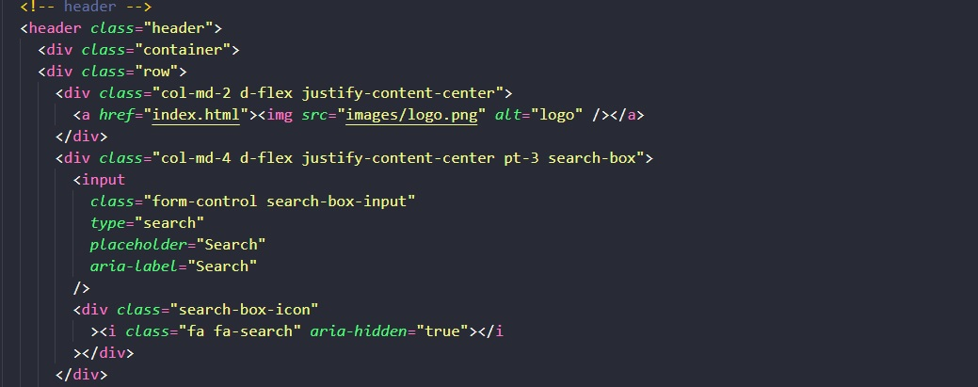

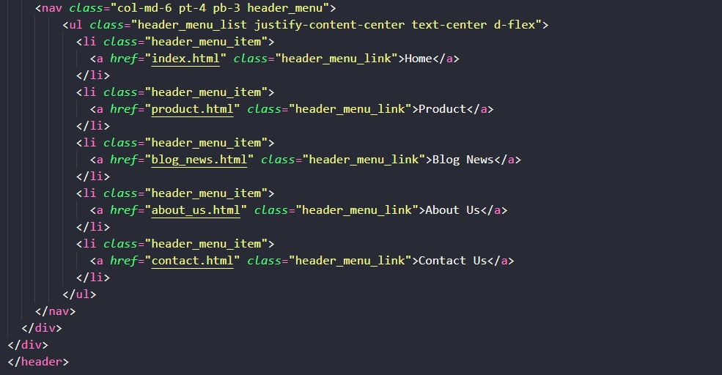

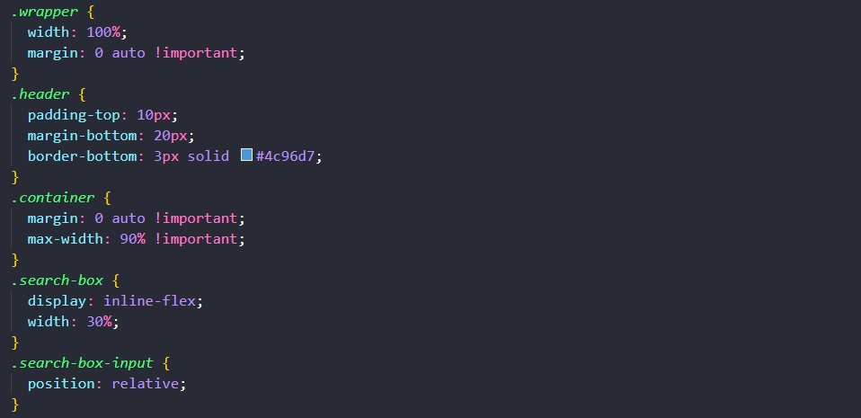

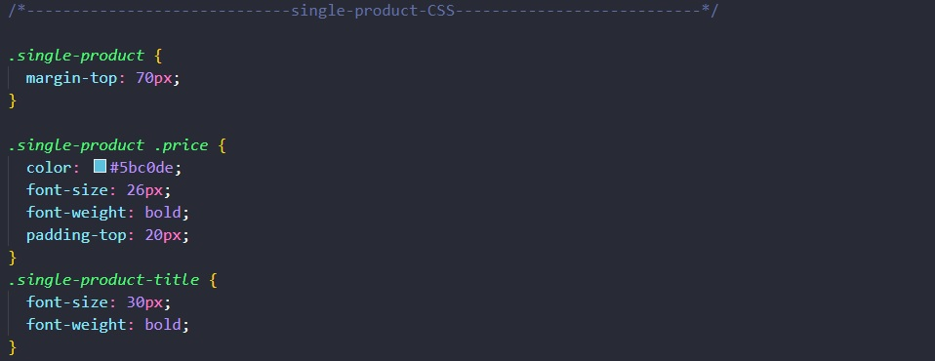

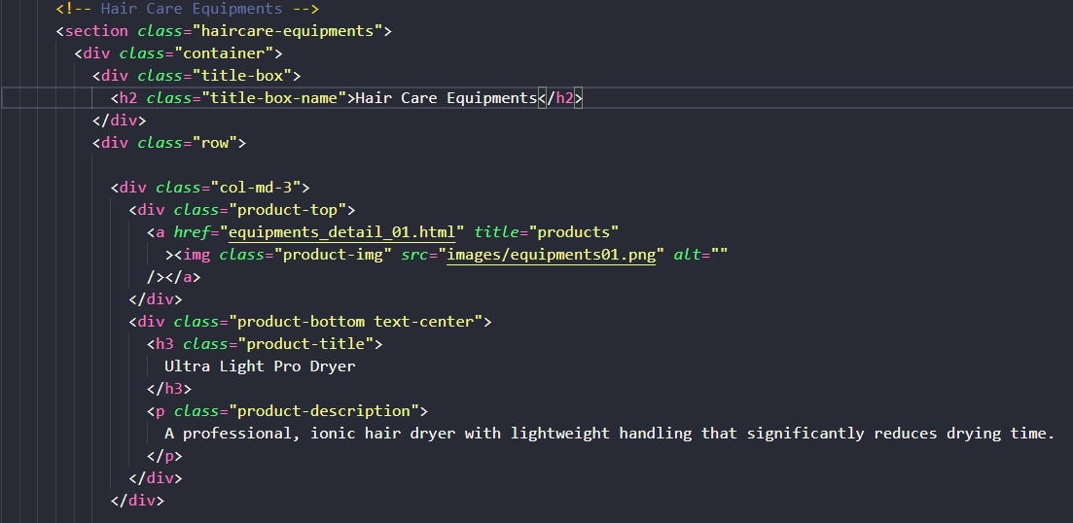

# TASK SHEET REVIEW 3

|  |  |  |  |  |  |  |  |
| --- | --- | --- | --- | --- | --- | --- | --- |
| ***Project Ref. No.:***  ***eP/Advertisement Portal Management System/01*** | | ***Project Title:*** | ***Activity Plan Prepared By:*** | ***Date of Preparation of Activity Plan:*** | | | |
| ***Sr.***  ***No.*** | ***Task*** | ***Actual Start***  ***Date*** | ***Actual Days*** | ***Team Mate***  ***Names*** | ***Status*** |
| *1* | *Home page* | ***HairCare*** | ***Khanh*** | 12-Mar-20 | *2* | *Khanh* | *Completed* |
| *2* | *Contact Us* | 14-Mar-20 | *1* | *Nam* | *Completed* |
| *3* | *About us* | 18-Mar-20 | *1* | *Quang* | *Completed* |
| *4* | *Product* | 16-Mar-20 | *2* | *Khanh* | *Completed* |
| *5* | *Blog news* | 19-Mar-20 | *1* | *Nam* | *Completed* |

|  |  |
| --- | --- |
| **Date: 15/10/2020** | |
| Signature of Instructor:  **Mr. Nguyen Phat Tai** | Signature of Team Leader:  **Mr. Vu Duy Khanh** |